Ayurvedic Retreat

Incredible trip to immerse yourself in authentic Ayurveda.

Ram & Sonali want to share their own journey through Ayurveda by leading a small group back to a personally recommended Authentic Ayurvedic Retreat 5th-25th February 2024.

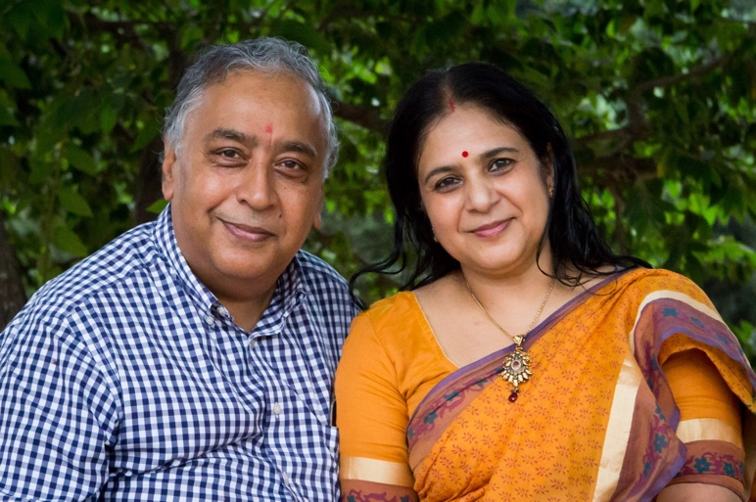
Let Ayurveda, a 5000-year old healing methodology, rejuvenate you and reset you to your health birth-right so that your body and mind can best heal any ailments you may have.

Personalised treatment in the form of a 3 week ‘pancha-karma’ at SDJ Ayurvedalaya set in the serene, peaceful and lush greenery nestled in the foothills of the Nilligiri mountains in southern India.

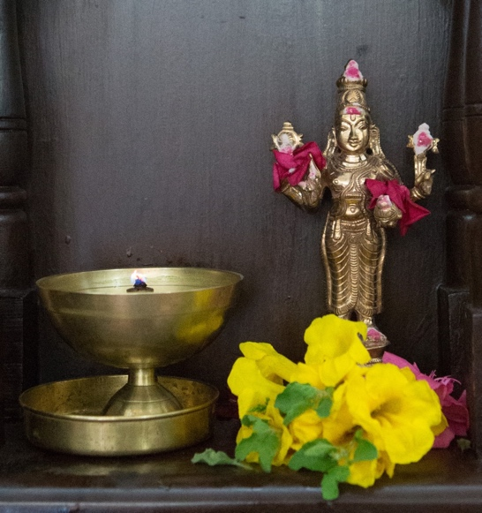
Place yourself in the hands of eminently qualified Vaidyas (Ayurvedic Doctors) and staff led by Internationally known Dr Parthasharathy who will be speaking at the World Yōga festival in 2023.

If you wish to tour India at the same time, it is recommended that you finish your tour with the treatment.

The SDJ centre is 40km (1.5 hr drive) from Coimbatore airport or 180km (4.5 hr drive) from Cochin International Airport. Airport transfers can be arranged on request. Non-Indian nationals will require a visa to enter India. Flights, visas and airport transfers are not included in the prices quoted below.

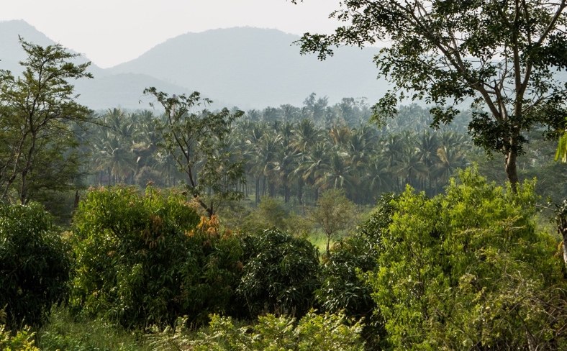
During treatment, it is recommended that all other activities are minimised. However, Ram will be running afternoon classes and satsangs on aspects of Advaita Vēdantā and meditation throughout the stay for those that are interested to participate.

There will also be an opportunity to visit Swami Dayananda’s ashram which is just 2km away.

Food
Vegetarian food, which is both tasty and plentiful, is prepared and served in your room according to Ayurvedic principles and matched to the treatment needs of guests.

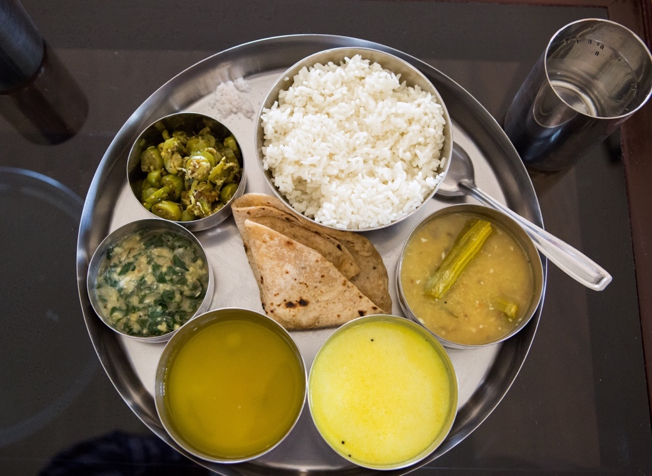

Accommodation
Rooms to suit all budget from single rooms to detached cottages. All rooms have individual beds and en-suite bathrooms. Many rooms have air-conditioning (although not strictly needed in February). Rooms are as follows:

Single room (0 available)
Well-lit airy single room on ground floor offering a comfortable and economical stay.
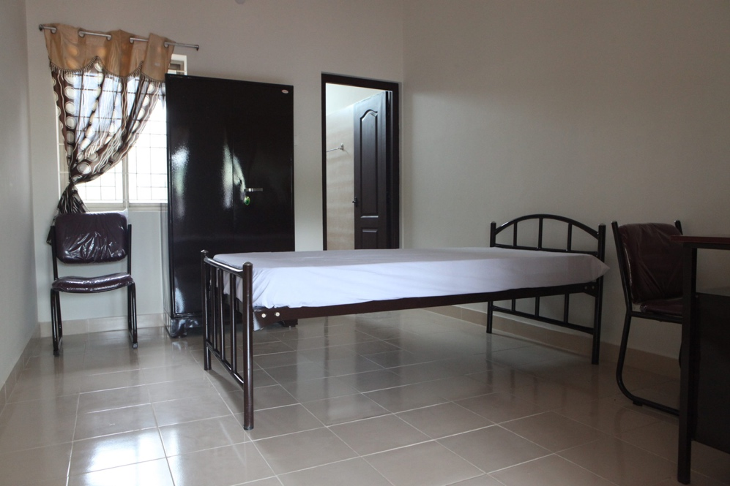

Description:
- 19m² Room
- 1 person
- Single bed
- Ceiling fan
Sold Out
- Electric kettle
- Private bathroom

Cost: £1000 for 3 weeks (incl. accommodation, food and treatment)

Twin room (1 sold, 2 available)
Spacious and airy room on ground floor.
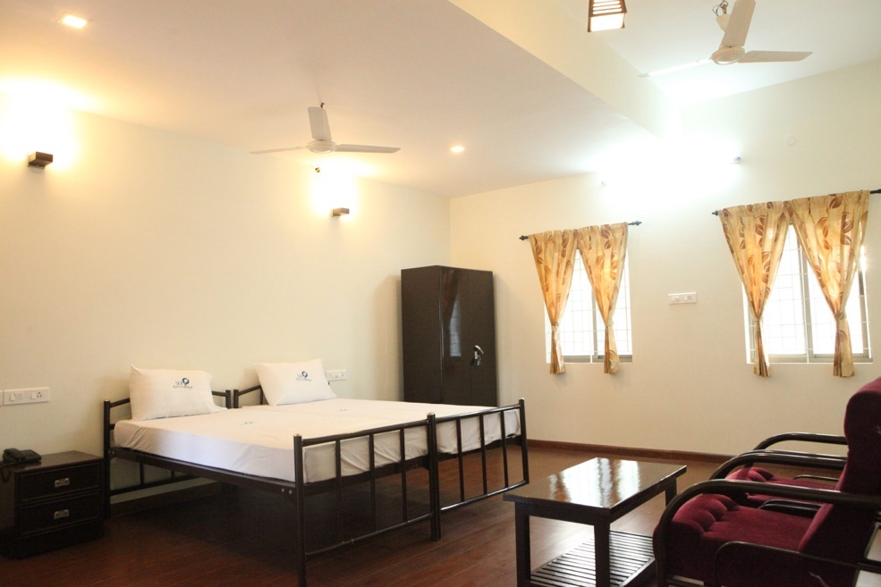
Description:
- 38m² Room
- Up to 2 people
- Twin beds
- Ceiling fan
- Electric kettle
- Private bathroom

Cost: £1100 per person for 3 weeks (incl. accommodation, food and treatment).
£100 Single occupancy supplement.

Deluxe A/C room (1 sold, 1 available)
Spacious & comfortable room on the ground floor with cosy furniture and dressing room. Opens to a semi-private garden.

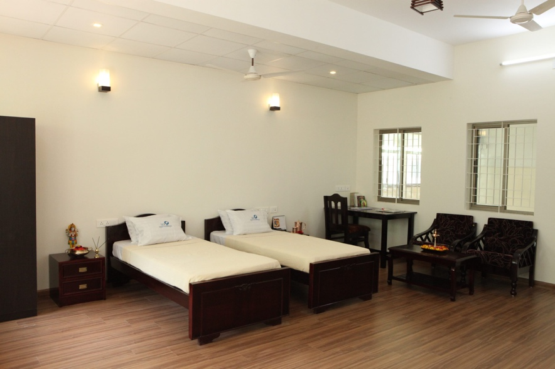

Description:
- 38m² Room
- Accommodates up to 2 people
- Twin beds
- Air Conditioning
- Ceiling fan
- Electric kettle
- Private bathroom

Cost: £1200 per person for 3 weeks (incl. accommodation, food and treatment).
£150 Single occupancy supplement

Premium non-A/C room (4 sold, 0 available)
Well-lit and spacious room on the first floor offering more privacy and veranda with seating and 180-degree countryside views.
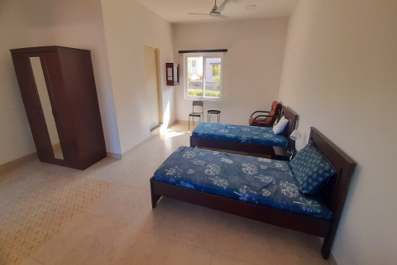

Description:
- 33m² Room
- Accommodates up to 2 people
- Twin beds
Sold Out
- Ceiling fan
- Electric kettle
- Private bathroom

Cost: £1250 per person for 3 weeks (incl. accommodation, food and treatment).
£200 Single occupancy supplement

Premium A/C room (2 sold, 1 available)
Well-lit and spacious room on the first floor offering more privacy and veranda with seating and 180-degree countryside views.
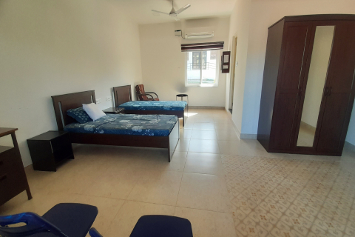

Description:
- 33m² Room
- Accommodates up to 2 people
- Twin beds
- Air Conditioning
- Ceiling fan
- Electric kettle
- Private bathroom

Cost: £1350 per person for 3 weeks (incl. accommodation, food and treatment).
£200 Single occupancy supplement

Surya Cottage (0 available)
The tastefully designed one-bedroom private cottage has a private deck that overlooks the forest and enables one to witness a beautiful sunset. (Two steps to the outside that may not suit elderly people).
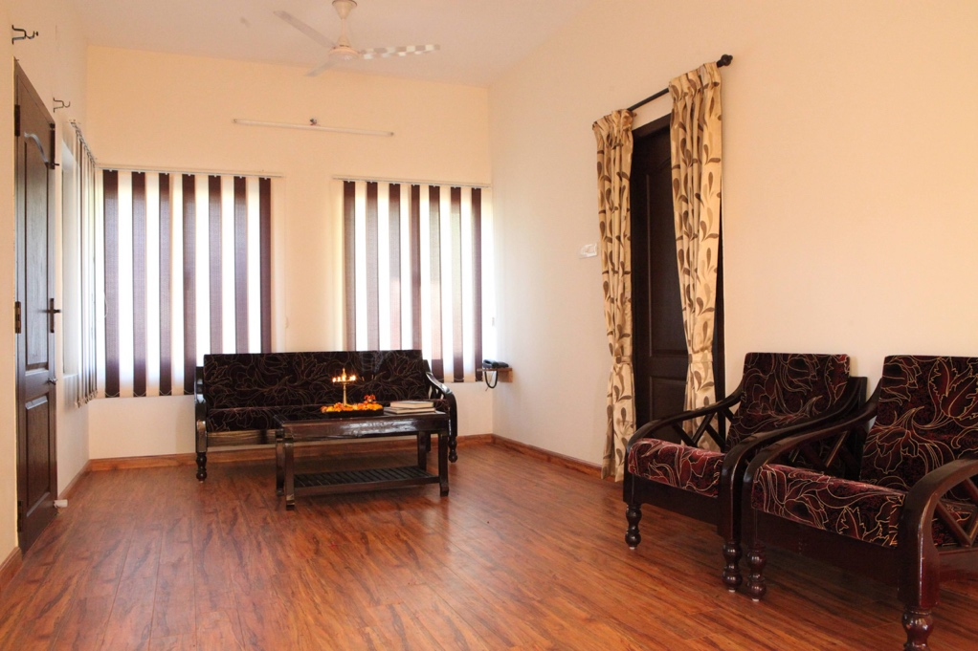

Description:
- 75m² bungalow
- Living room
- Kitchenette
- For up to 2 people
- Twin beds
Sold Out
- Air Conditioning
- Ceiling fan
- Electric kettle
- Washing machine
- Private bathroom

Cost: £1600 per person for 3 weeks (incl. accommodation, food and treatment).
£300 Single occupancy supplement

Giri – Mountain View Cottage (only 1 available)
A nice private cottage where you can enjoy the fantastic panorama of the mountains from the cottage, more specifically from the sit out.
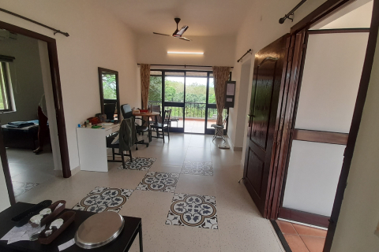

Description:
- 65m² bungalow
- Living room
- Kitchenette
- For up to 2 people
- Twin beds
- Air Conditioning
- Ceiling fan
- Electric kettle
- Washing machine
- Private bathroom

Cost: £1600 per person for 3 weeks (incl. accommodation, food and treatment).
£300 Single occupancy supplement.

Treatment

The cost of treatment is included in the accommodation prices quoted. Although 3 weeks is recommended, 2 weeks is the minimum for treatment.

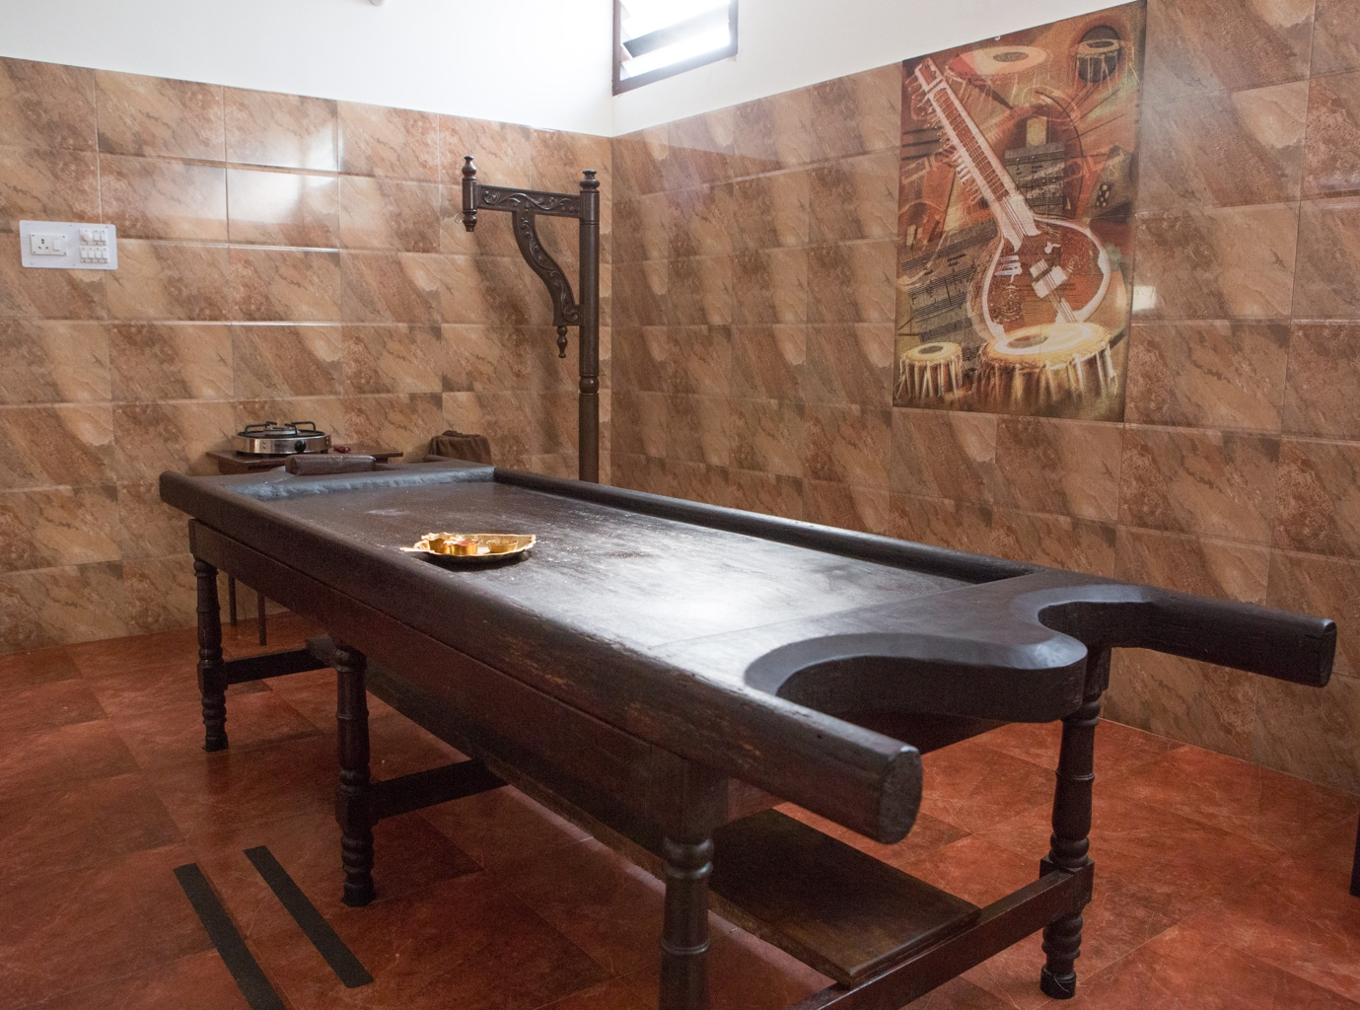

Next steps

If this is of interest and you have other questions, then please contact us at

contact@yogafestival.world

All room choices will be made on a strictly first-come basis.
Reservations can be confirmed (stating your room choice) with a non-refundable £200 deposit made to:

Arsha Kula Foundation
Sort Code 23-05-80
Account No. 23496968

We will then confirm your choice of rooms.
The balance may be paid in two equal instalments by 1st September and 1st November 2023.

Additional Information
This is the general information provided to all patients. You will be expected to state that you have read and understood the following prior to your treatment starting.

- “Brahma Muhurtha” is roughly between 4.00 AM and 6.00 AM & we request you to be up by this time & hence you will have to go to bed early which is re-emphasized later.
At around 5.45 AM or earlier, after cleaning/gargling your mouth with water, you can drink around 100 to 200 ml of room temperature water sip by sip. After 15 minutes at 6.00 AM, you would usually have warm medicine to drink.
- “Dasanakanti churnam” a medicinal tooth powder made of 15 herbs is highly suggested instead of toothpaste. Can buy more in the pharmacy if needed.
- Evening Chanting or Prayer session will be at 5 Pm and you can join if interested. On Thursdays, if you are welcome to join our “Bhajans” we request you to consume the medicines before the Bhajan so that there would be a gap between the medicine and the prasadam offered at around 6 PM.
- You would be finishing your dinner around 7.45 PM & the best time to go to bed would be around 9 PM. Early to bed helps to get up at “Brahma muhurta”
- We request NOT to engage our staff for your personal work like drying your clothes, buying things from the market etc but in dire need, our office can help
- Smoking, Using Tobacco, Taking alcohol or any other types of drugs are prohibited during the treatments, inside the campus.
- There would be a lot of free time here and our approach is NOT to keep you engaged with back-to-back treatments or activities. Our suggestion is to introspect and internalize and have some "do nothing moment" rather than getting occupied.
- Attend to natural urges without any delay. These include yawning, burping, passing flatus, thirst, crying, urination and evacuation. At the same time do not initiate the urge forcefully. Inconsistency in the time of evacuation is common during the treatments.
- In any event of leaving the campus gate, you are requested to take consent from the Vaidyas.
- Your blood pressure would be monitored regularly, weight would be measured once a week and our primary weighing machine stationed near Room 4.
- If you are a diabetic, you should monitor your blood sugar with your glucometer frequently and if you do not have one, we can help to check with our glucometer for INR 50 per check.
- We are staying amidst the forest and despite electric fencing, wild animals including Elephants, Wild boars, wild buffalos, deer, peacocks and snakes are present and so we request you to be watchful & not to go for walks and treks into the wilderness & to the non-illuminated area during nights. However, it is safe to the extent of many staff/ families stay on the campus with kids
- Our “Green” campus works on solar energy but the Air conditioners in all rooms & hot water heaters in very few rooms are on regular government electricity support which tends to be erratic. You can contact our office in case of any inconveniences with it. While using Air conditioners, please keep the doors and windows closed.
- Our Admin Person meets you every Monday and Friday to make a list of Maintenance & Non-Medical issues/requirements. If any most essential items need to be purchased, you can request them at that time and it would be arranged with a service charge of INR 50. However please hire a taxi for your urgent or specific requirements that cannot be sourced locally.
- You can contact our office to get the internet connection which is charged at Rs 50 per day.

Laundry & Ironing
Self-use Washing Machine
We have a Washing machine kept in the Laundry Area (near Room 4), Two machines are kept upstairs and individual washing machines are kept in each cottage. These machines will wash and semi-dry your clothes. Washing powder/liquid is made available in the amenity box and Rs 50 is charged for each wash.

There are two covered cloth hanging facilities both on the ground floor and upstairs. Cottages will be provided with Drying racks.

We have an ironing board and an Iron box or Dry Iron Machine placed in the Laundry Room both in the ground floor and upstairs and you are free to use them when needed but please make sure you switch them off after use. We do not have any other outsourced ironing facility.

Beddings or Bed Linens & Towels
Bed linens and pillow covers are changed on Tuesdays and Fridays for Rooms 1 to 9. And on Wednesdays and Saturdays for upstairs and cottages.

We take special care to provide clean Bedsheets and Pillow covers but as the treatments are primarily oil-based, there can be minuscule oil stains or smell retained on the bedsheets and pillow covers even after going through the industrial laundry with biodegradable chemicals.
In case you are not comfortable using them, please feel free to bring your sheets and pillow covers and you can take care of laundering your personal linens.

We have placed 5 Brand new towels in your wardrobe, & they are washed once to remove the starch and your Name or Initial is marked on the corners to identify when you put them for drying.

Treatments related
- During treatment, there is a common misconception that people will feel good day by day, but, with all the changes happening due to the treatments, one can experience a sense of tiredness during the treatments and in a few cases, there can be a temporary exaggeration of the presenting complaints also. Fluctuations in blood pressure, blood sugar, sleep, evacuations, hunger etc are common.
- The extent of cure and time taken to experience the betterment depends upon the nature of a person, the nature of the problem, the chronicity of the problem, associated ailments, thoroughness in following the physician’s advice, Mind-set of the person, Faith of the person and even the astrological time cycle which is influencing the person.
- Generally, it is seen that most patients respond positively 3 months after the completion of treatments as it takes time to get back to the normal rhythm. Ayurveda is not a magical system that can guarantee a complete cure for all diseases with Panchakarma treatment.
- Ayurveda treatments are not immediate alternatives to allopathic medications & one cannot expect to quit one’s allopathic medicines by the end of or during the treatments. One might have to continue the regular allopathic medicines until advised otherwise. Please ensure you bring a regular supply of allopathic medication for the entire duration of your stay.
- We cannot predict the outcome of the treatments as it could be appreciated only after the treatments and we do not offer any guarantee on outcome.
- During Ayurveda treatments, to enjoy the goodness of the treatments, we request you to be an observer of treatments and processes instead of inquisitively trying to analyse the treatments even if you are very knowledgeable about Ayurveda. Also, we do not encourage questions like “What is my Prakriti? What is my Dosha?” etc which are huge topics that need a lot of explanation.
- A peaceful and positive mindset is required to get the full benefit from the treatments. Avoid subjects, topics, activities, thoughts & situations that may contribute to the provocation of emotional outbursts. Faith in Ayurveda and faith in the treatments offered will also contribute to results
- Treatment type, Treatment time, Treatment room and allocation of therapists are at the discretion of the vaidyas and it is not possible to meet your special preferences. There are various treatment slots during the day from 9.00 AM until 5.15 PM and your treatment slot can be at any time based on availability.
- We do not suggest any physical activity that produces exertion during your stay here for treatments, including the strenuous Yoga Asana as they would be counterproductive for the treatments. However, you can continue a few simple and relaxed asana practices, if its gentle. Pranayama and Meditation can be complimentary. Sexual activity is contraindicated. Reduce energy drain by avoiding intense discussions, gadget usage, internet usage, reading, writing or thinking
- Time consumed for a bath after your treatments have a crucial impact on our operations in addition to impacting other people's treatment, therapist availability and so on. We want your bath to be finished in a maximum of 15 minutes & the steps involved are mentioned below.
- Step 1- Therapists will wash your head with your shampoo ( from your room) using lukewarm water (NOT HOT) & (for ladies) tie the head with a towel - For 5 minutes
- Step 2 -While sitting on the stool, the bath paste will be applied all over the body. Therapists would rub the paste on your back and legs & you can rub yourself on your upper body and private parts. Therapists pour hot water and help you wash off the bath paste - 8 minutes.
- Step 3 - You can stand holding the handrail and more water would be poured to help wash the leftover bath paste- 2 minutes.
- Optional Step 4 but not preferred- You can use more water to wash by yourself for a max of 2 more minutes or go to your room to continue and finish with a quick bath
- Another additional bath/shower in your room is not advised as it might lead to Flu/Common Cold because of oil-based treatments. If you are very particular about your morning bath, we suggest taking a quick body wash leaving the head. Please note that we have to stop the external treatments if one has a tendency to have a common cold/ flu, Nasal congestion, running nose, sinusitis or fever.
- Please wear easy to remove garments to the treatment room and you can either come back with the same garment and change to new in your room or take a quickly wearable garment as a changing cloth.
- Immediately after the treatment/ bath, we suggest you dry your hair completely. You can use a towel/hairdryer and a few hair dryers are available in common areas and please return after each use
- Exposure to sun, wind, rains, cold weather etc is not advisable during the treatments and if you wish to have a gentle and relaxing walk around the campus, please select the time of the day which is suitable. The night walk is contraindicated as it would be cold, and also because of the animal movements in this locale. There might be a few treatment specific restrictions in addition to this & it will be explained by the Vaidyas as & when required.
- If you are in an Air-conditioned room, please do not use them at least 2 hours before and 2 hours after the main treatments. Even during the other periods please use them close to the outside temperature and only on need.
- Women on the menstrual cycle (bleeding) will not have any external treatments and female patients are advised to plan their arrival considering the menstrual cycle.
- Considering the time needed for recovery as mentioned in the previous point, on getting discharged from here and on reaching home, we advise you to take a good period of rest after discharge before gradually going back to the normal busy routine of life.

Food Related
It is so important to adjust the quantity of food based on your hunger at mealtime & at the same time you have to stick with the mealtime. If you are NOT hungry at a particular mealtime, take just a few spoons of food. Of course, it’s not good to waste food but in the context of better treatment, don’t feel bad about waste, we will use it to feed animals and birds.
Food timings

Breakfast - 7.30 for Ground floor, 7.40 for Upstairs and Cottages
Lunch- 12 noon for Ground Floor, 12.20 for Upstairs and Cottages
Snack- 3.30 for Ground floor, 3.45 for Upstairs and Cottages
Dinner- 7.15 for Ground floor, 7.30 for Upstairs and Cottages

Breakfast & Dinner would be simple and Lunch is the main meal of the Day, Snack would also be very simple like a small serving of herbal juice, herbal Drinks, Herbal soups etc.
Avoid overeating and eating before the previous meal has been digested. Avoid eating too quickly and swallowing without chewing. One has to stop at satisfaction and not after the stomach is full.

We take an extra workload on us to serve the food in your room and not in a common dining area where one would tend to externalize by talking, socializing etc. We wish your eating should be like a ritualistic/ meditative process with a complete focus on food and completely connected with the food. Even while having a meal with others, please do not talk or discuss.
We do not provide a zero sugar diet even to a person who is diabetic as cutting sugars is just escaping from the problem but our approach is to handle the problem.

We do not provide any special meal options. We have our standard 7 day diet plan that mainly focuses on being conducive to treatment. Our meal also has Onion and Garlic sometimes and it would NOT be possible to give an Onion-Garlic free meal or any customized meal.

The quantity of serving is fixed and we would NOT be able to serve extra items due to operational difficulties and availability as each meal is freshly cooked. What is served regularly is a standard serving size and if needed we can increase or decrease to suit your requirement as a standing instruction.

What is a small serving size? We would reduce the quantity of the main dish like Rice, Dosa, idly or the item served in the big bowl.
What is a big serving size? We will increase the main dish like Idly, dosa, rice etc and proportionally increase the quantity of vegetables and gravy. For lunch, one can increase one chapati to two for lunch.
Please discuss with the doctors to alter the serving size. Switching the serving size can be accepted twice during your stay.

The food that is best suited during the treatments will be served by us with the utmost care and efforts to bring varieties and also to suit different palates and we advise you to get along with our food regime. In case of issues in taste, quantity, varieties etc you can buy fruits like Pomegranates, Apples or Guava for standby and our office can help you buy them if available locally with a small extra service charge but they cannot do it immediately and it may take one or two days to arrange.

Water-Related
Water should be consumed based on thirst. Do not overdrink.
Drink at least 100 ml to 200 ml of water with food, sip by sip and it can be even more but try to avoid drinking water immediately after food for around 50 minutes.

The water for drinking and cooking is well purified with the best technology and the ones served in the Jug is non-boiled purified water. We suggest you use boiled water for drinking. Not just for hygiene purposes but as a treatment recommendation. You can consume the boiled water warm or even cool down to room temperature. Please note that the water boiled and kept overnight is not good for consumption the next day as per Ayurveda.

Purified water both Hot and Normal are made available in a common space both in the first floor and upstairs. Purified water storage containers are kept in all the cottages.

Water Jug and thermos are provided to store your water. Additionally, a Hot water kettle is provided to boil water. Dishwashing Soaps and scrubs are made available in the Amenity box for cleaning your utensils as we do not change them until discharge.

After the meal
Immediately after each meal, take a relaxed walk/ stroll with around 50 steps and not more than 100 steps. After this, it's better if you rest for around 20 minutes in a sitting/ reclined position or if you feel very tired, you can lie down on your left side.

DO NOT SLEEP as sleeping during the day is contradictory for the treatment and more specifically sleeping after food is TOTALLY against the treatment however if one is too sleepy after lunch, then sleeping for 20 minutes approx in a sitting/ reclined posture is acceptable.
If one is so tired during the day or sleepy because of insufficient night sleep, one can sleep for around 1 hour but definitely before lunch or much after lunch. The best time for it would be around 11 AM or around 4 PM.

Medications related
You can consume the medicines with a prayerful mind, preferably after a short prayer to Lord Dhanwantari. It’s your choice to brush your teeth before or rinse/swish your mouth before the 6 AM medication.

Please keep the used medicine containers in the tray and leave them outside your room before 10 Am.

Unlike Modern Medicine, our medicines do not have a one to one relationship with the disease but are based on the concepts of Ayurveda which are holistic and we would not be in a position to explain the purpose of each medicine prescribed and the common medicines that you consume during the treatments are as follows

Kashayam :
Kashayam is an ayurvedic formulation prepared by taking aqueous extract by boiling raw herbs/drugs in water.
Kwatham/Kashayam tablet :
Kashayam tablet is a relatively new concept in Ayurveda to make Kashayam into tablets with improved shelf life and convenience to carry and consume.
Arishtam and Asavam :
Arishtam and Asavam is a concept based on controlled natural Alcoholic fermentation of herbs in a sugar medium.
Choornam :
Choornam is a fine dry powder of herb or combination of different herbs mentioned in the classical formulation.
Gritham :
Gritham is a Medicated ghee prepared by boiling the ghee, medicinal herbs in various forms, liquids like water, kashayam, Juice, milk etc.
Gulika / Vati / Guggulu :
Powders of raw drugs are triturated together with certain Kashayam or Juice or even honey and prepared in the form of pills or tablets.
Lehyam and Rasayana :
It is a semi-solid formulation prepared with herbs, juices and decoction, adding jaggery or sugar syrup & later, spices, honey etc are added as per the formulation.
The primary substance used for External treatments are medicated oils which are commonly called as Thailam.
Tailam is prepared by adding Kalka (herbal paste), kwatha (herbal decoction), and drava dravyas(liquids) to oil in specific proportions & subjecting them to a specified heating pattern which could go up to 5 days. By this process, one can ensure the transformation of the active therapeutic properties of the ingredients to the oils.

TIPPING THE STAFF
As we believe that tipping the staff might drive people to show partiality in the care and service offered, we wish you DO NOT tip them directly. If you wish to tip them, you can drop it in an envelope with your name in the staff fund box in the office and it would equally reach all the workers here except the managerial personnel. Though we prefer to offer this equally to everyone, if you wish to offer special tips to a particular person, you can mention a note in the envelope.

SDJ Ayurvedalaya is strictly an Ayurveda treatment centre/Hospital, hence please do not expect the facilities of a resort.
WE WISH YOU A COMFORTABLE HEALING STAY AT SDJ AYURVEDALAYA!

